*22AIE204 Introduction to Networks*

Labsheet6

Building Network in Packet Tracer

Name : Anuvind MP

Roll no : AM.EN.U4AIE22010

**----------------------------------------------------------------------------------------------------------------------------------------------**

**Problem 1)**

Build a small, wired network with 2 end devices only. End devices can either be laptop or desktop PC. You can use the IP address space 192.168.10.0/24 for assigning the end devices. Ensure that you give screenshots with title having your name and roll number and ping successful status as shown below. Follow this instruction throughout all the submissions of packet tracer problems.

**Answer :**

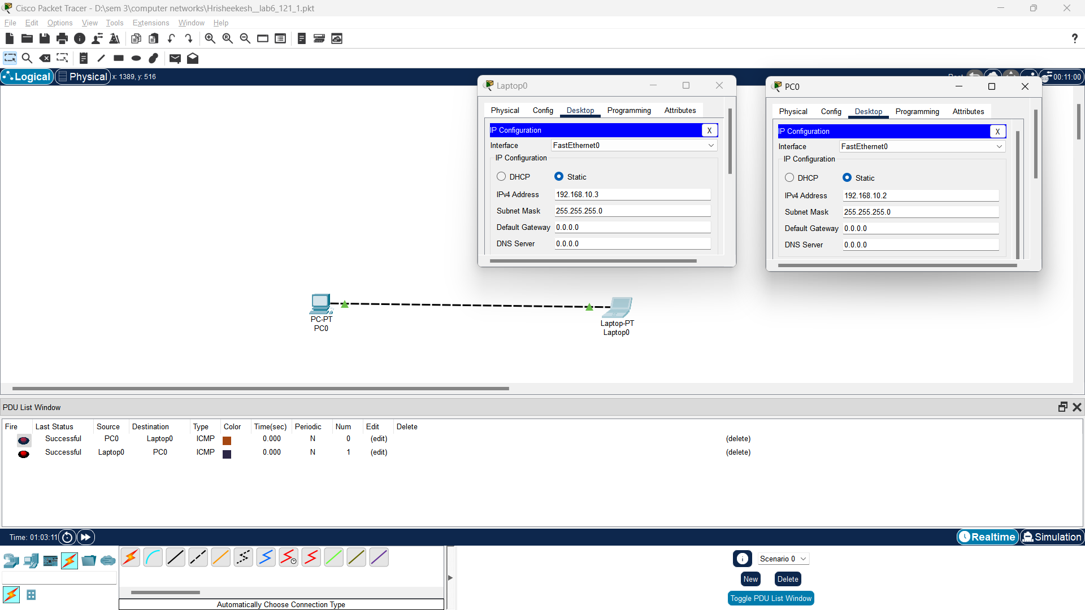

**Problem 2)**

Build a small, wired network with more than 10 end devices. You can use the IP address space 192.168.10.0/24 for assigning the end devices. Hint: use networking device switch to create a local single network

**Answer :**

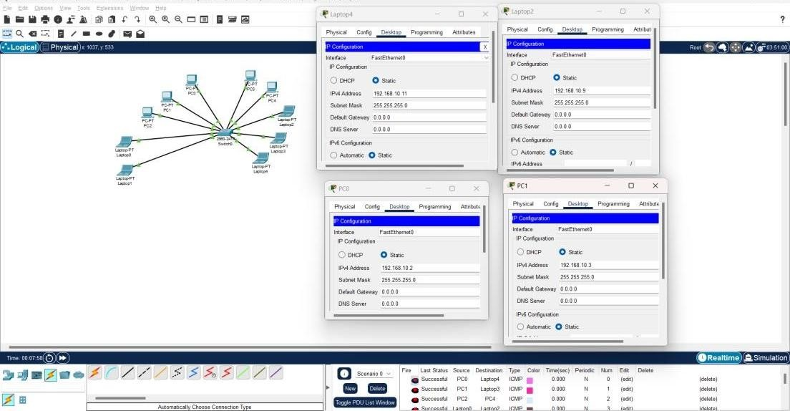

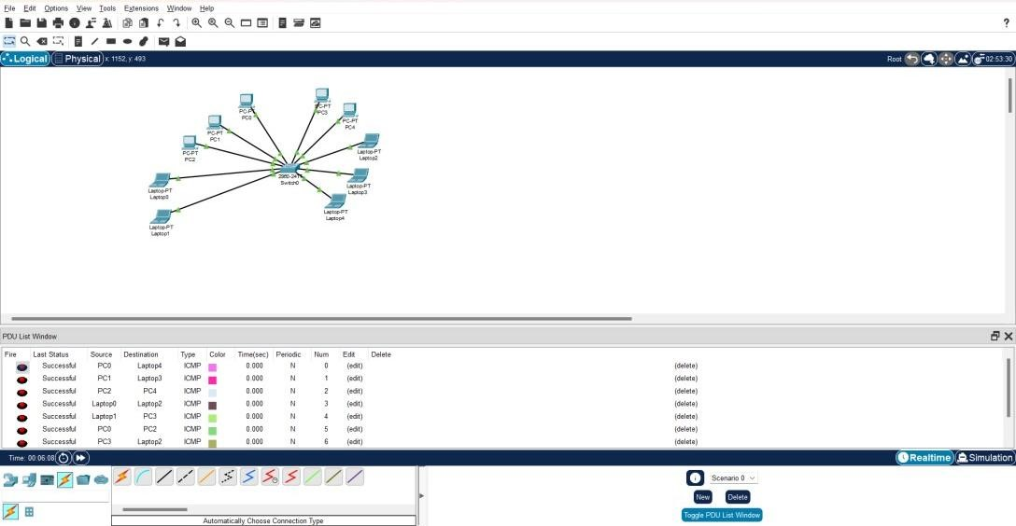

**Problem 3)**

Build two small, wired subnets with around 120 hosts. Each subnet should have at least two end devices. You can use the IP address space 192.168.10.0/24 for assigning the subnets. Hint: use networking device router to create two subnets.

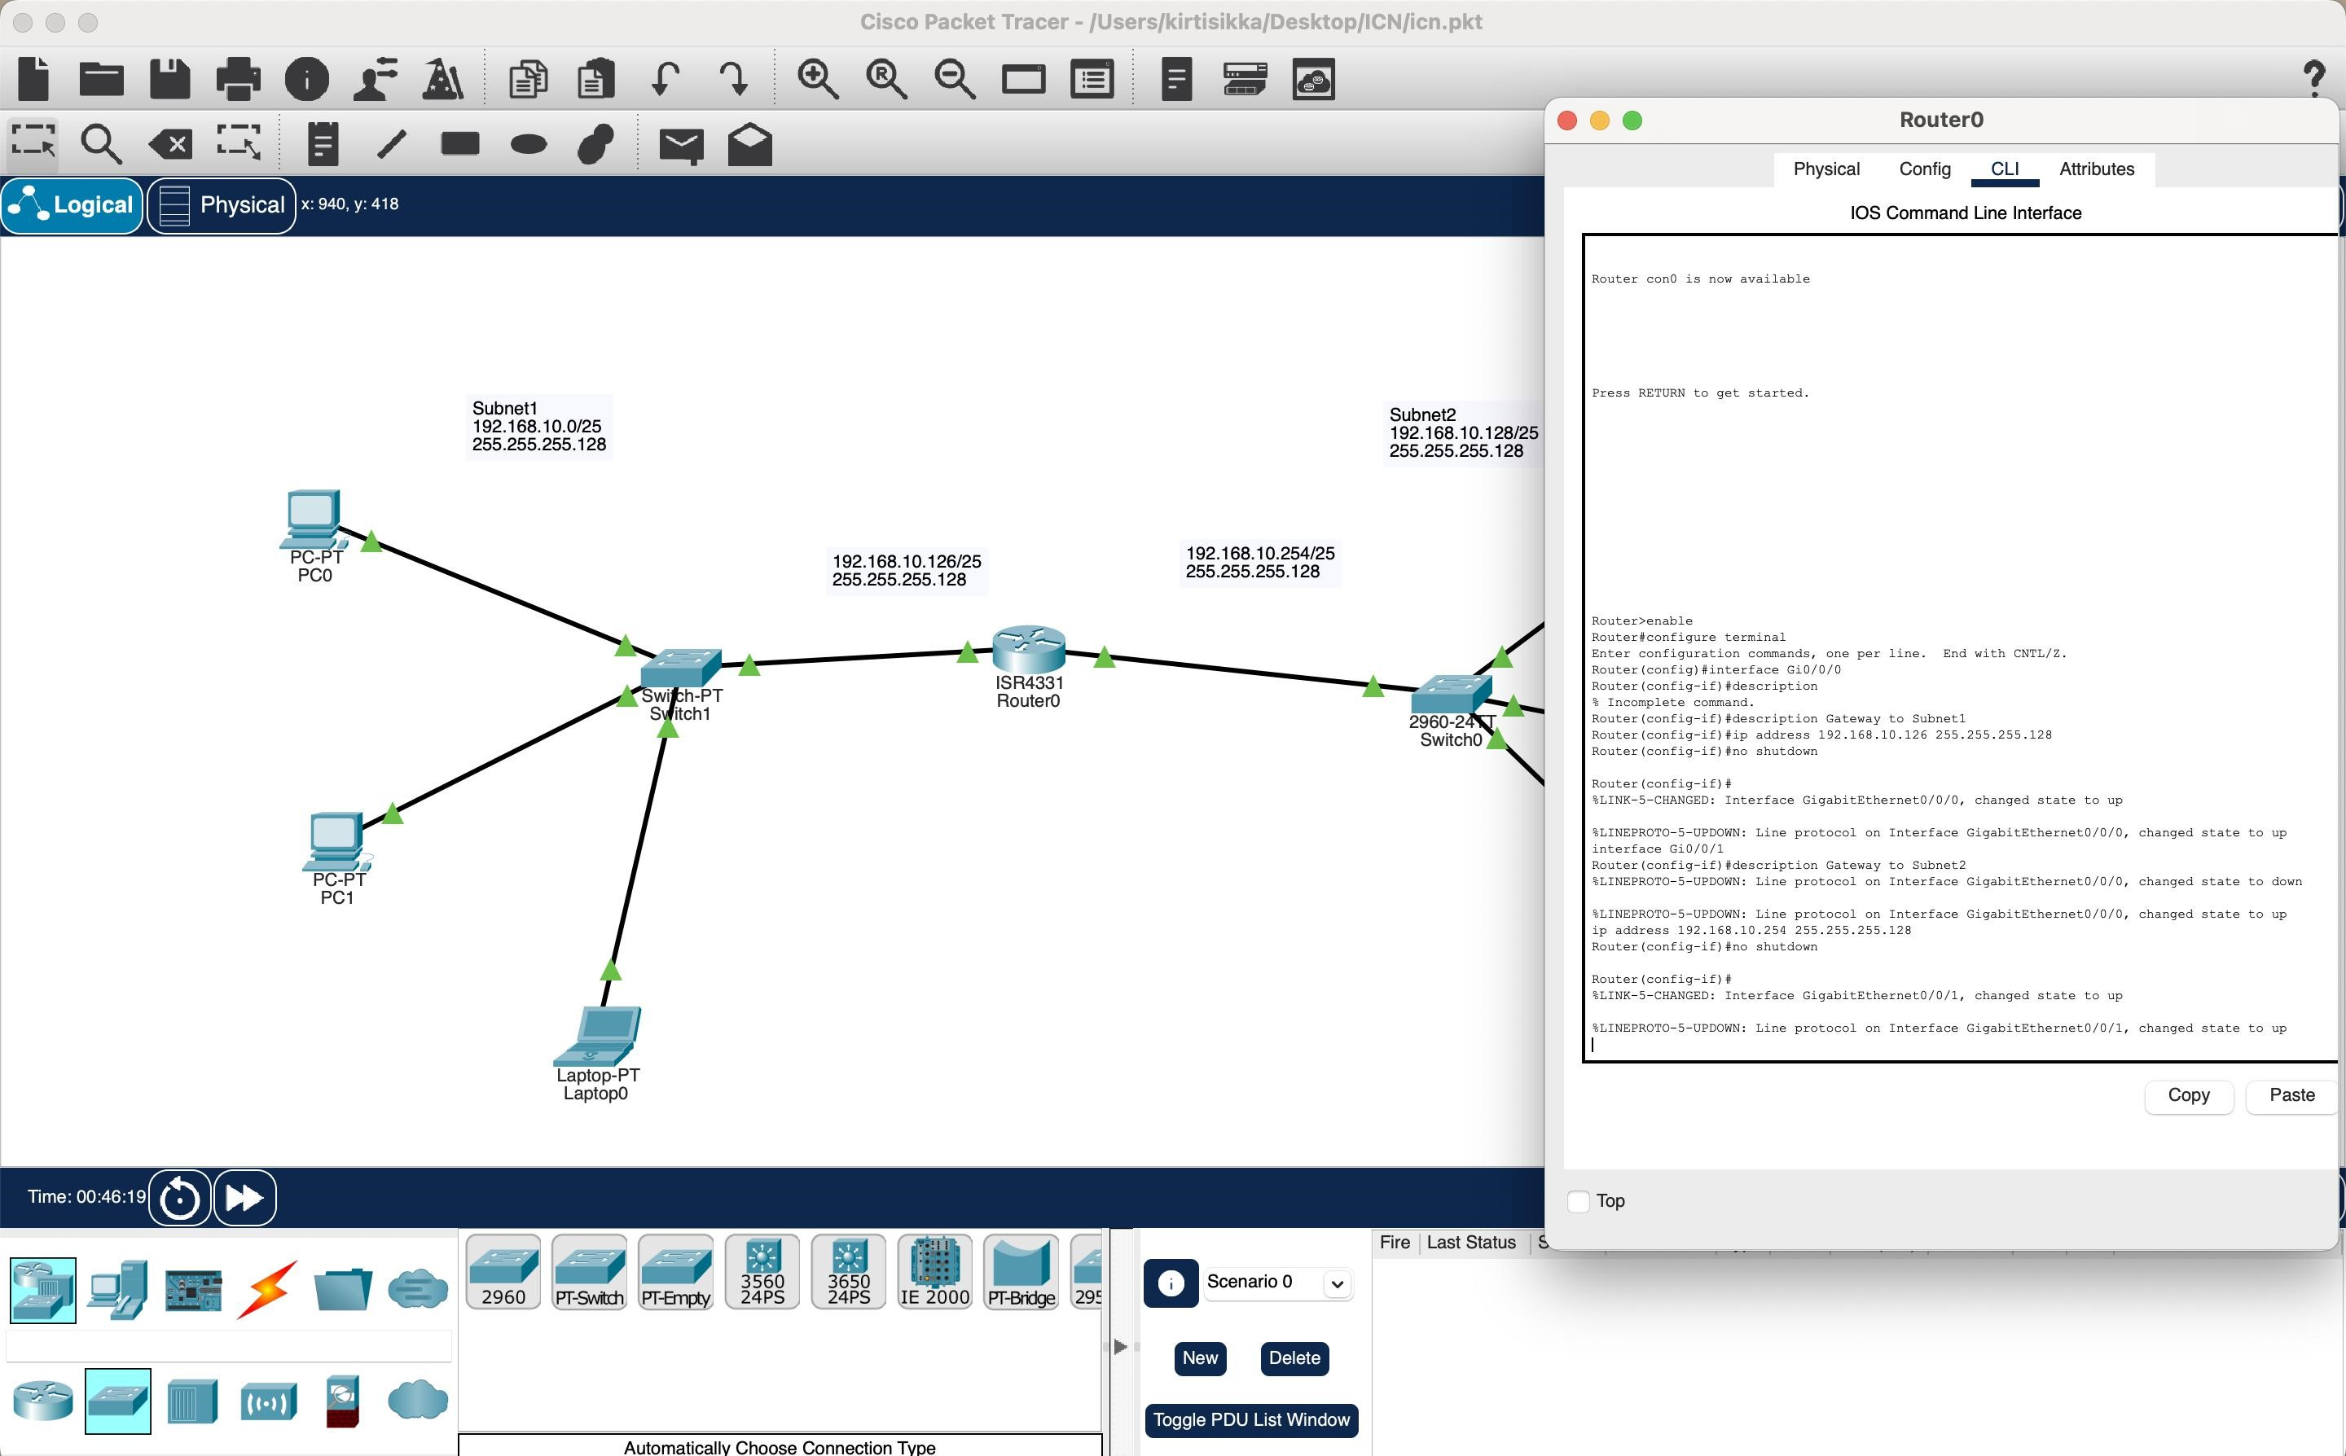**Answer :**

